Optimal Broadcast with Partial Knowledge
Baruch Awerbuch, Israel Cidon, Shay Kutten, Yishay Mansour,
and David Peleg
Siam Journal of Computing, Vol. 28, No. 2, pp.511-524
Abstract
This work is concerned with the problem of broadcasting a large message efficiently when each processor has partial prior knowledge about the contents of the broadcast message.
- Introduction
The broadcast with partial knowledge problem can be formulated as follows. Consider an asynchronous communication network, consisting of n+1 processors, 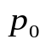,….,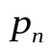; each processor 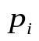has an m-bit local input 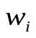, and processor is distinguished as the broadcaster. In a correct solution to the problem all the processors write in their local output the value of the broadcaster’s input, w=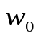.
- Preliminaries
Theorem 2.1. For any m and dm/3, there exists a check-bit code 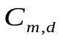 with the following properties.
- The check bit syndrome is of length 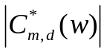 = O(d log m).
- The code is d-correcting.
- The encoding and decoding operations ( and 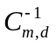, respectively) require time polynomial in m and d.
- Upper bound
  - Algorithm MAXIMUM
Given the value of 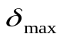, there is a deterministic algorithm for performing broadcast with partial information that requires 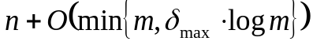 time and has communication complexity 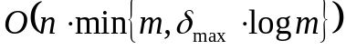.

  - Algorithm AVERAGE.
Algorithm AVERAGE has expected time complexity O(n+m) and expected communication complexity of O(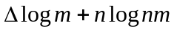) bits.

  - Unknown discrepancy
Algorithm UNKNOWN has expected time complexity 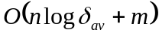 and expected communication complexity of 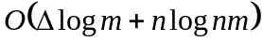 bits.

  - Optimal time complexity

- Low bounds
Theorem 4.1. The communication complexity of any broadcast algorithm is at least
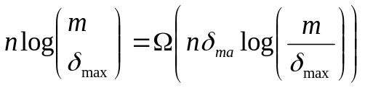
Theorem 4.2. The time complexity of any broadcast algorithm is at least
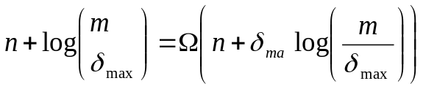
- Conclusion
Created by: Shin-Si Chen
Date: May 25, 1999

